Amniotic Fluid Stem Cells Aid Kidney Transplantation in Porcine Model
Review of “Amniotic Fluid-Derived Mesenchymal Stem Cells Prevent Fibrosis and Preserve Renal Function in a Preclinical Porcine Model of Kidney Transplantation” from Stem Cells TM by Stuart P. Atkinson.
Kidney transplantation is associated with ischemia/reperfusion (IR) which can lead to tissue fibrosis and transplant dysfunction [1], and previous studies in rodents suggest that amniotic fluid mesenchymal stem cells (afMSCs) are beneficial in protecting against such fibrosis [2, 3]. The group of Thierry Hauet at INSERM, France, have recently developed a porcine model of kidney autotransplantation which is comparable to the human situation with regards to anatomy and renal ischemia damage [4, 5]. Now, in Stem Cells Translational Medicine, they report a role for porcine afMSCs in protection against IR injuries in this model [6].
Porcine afMSCs collected at birth exhibited good adipogenic and osteogenic differentiation capacity in vitro, expressed MSC markers (CD90, CD73, CD44, and CD29), and had a poor capacity to differentiate into endothelial type cells. The addition of afMSCs during the reoxygenation step of an in vitro model of organ-preservation significantly increased the survival of endothelial cells, the main target of ischemic injury. Furthermore, addition of conditioned medium (CM) from afMSC/hypoxic human aortic endothelial cells (HAECs) co-culture to HAECs incubated on growth factor-reduced Matrigel induced a greater number of capillary-like structures compared to CM without the addition of afMSCs.
The researchers then assessed the potential therapeutic effects brought about by afMSC injection into the renal artery by evaluating renal function recovery in pigs by monitoring serum creatinine levels (See figure for general overview of the study progression). IR injuries following kidney transplants led to increased serum creatinine levels, and pigs injected with afMSCs demonstrated reduced creatinine levels and lower proteinuria (which correlates to glomeruli integrity), returning to pre-transplant levels by day 7 after injection. Histological analysis of grafts found that afMSC injection preserved the integrity of tubule brush borders, reduced levels of tissue-infiltrated cells and decreased tubular epithelial cell detachment, as compared to control untreated animals. Furthermore, an increased urine-to-blood osmolarity ratio suggested functional recovery of kidney reabsorption, while fibrosis was significantly reduced. This was all associated with a significant reduction in tubular atrophy at 3 months after transplantation.
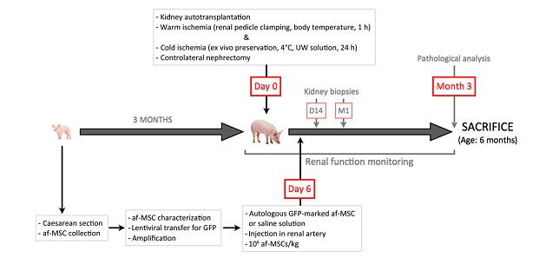
Assessment of potential pathways which mediate these positive effects found that afMSC injection induced higher levels of VEGFA (pro-angiogenic growth factor) and Ang1 (capillary structure strengthening and maintenance of vessel stability), and reduced Flt1 levels (potential decoy VEGFA receptor). TGFβ plasma levels were also elevated after afMSC injection, although cortical TGFβ levels in kidney grafts at 3 months after transplantation were elevated to similar levels in both afMSC injected and control animals.
These findings demonstrate the beneficial effects of afMSC injection on kidney transplant. The fact that afMSCs are a cell type which is easy to isolate, highly proliferative in vitro, secretes proangiogenic and growth factors, and differentiates into many cell lineages, including renal cells [7-9], makes this approach viable for potential clinical application. Furthermore, the study also highlights the porcine preclinical model as a powerful tool in the assessment of stem cell-based therapies in organ transplantation.
References
- Cicco G, Panzera PC, Catalano G, et al. Microcirculation and reperfusion injury in organ transplantation. Adv Exp Med Biol 2005;566:363-373.
- Perin L, Sedrakyan S, Giuliani S, et al. Protective effect of human amniotic fluid stem cells in an immunodeficient mouse model of acute tubular necrosis. PLoS One 2010;5:e9357.
- Hauser PV, De Fazio R, Bruno S, et al. Stem cells derived from human amniotic fluid contribute to acute kidney injury recovery. Am J Pathol 2010;177:2011-2021.
- Jayle C, Favreau F, Zhang K, et al. Comparison of protective effects of trimetazidine against experimental warm ischemia of different durations: early and long-term effects in a pig kidney model. Am J Physiol Renal Physiol 2007;292:F1082-1093.
- Rossard L, Favreau F, Demars J, et al. Evaluation of early regenerative processes in a preclinical pig model of acute kidney injury. Curr Mol Med 2012;12:502-505.
- Baulier E, Favreau F, Le Corf A, et al. Amniotic Fluid-Derived Mesenchymal Stem Cells Prevent Fibrosis and Preserve Renal Function in a Preclinical Porcine Model of Kidney Transplantation. Stem Cells Transl Med 2014;
- Perin L, Giuliani S, Jin D, et al. Renal differentiation of amniotic fluid stem cells. Cell Prolif 2007;40:936-948.
- De Coppi P, Bartsch G, Jr., Siddiqui MM, et al. Isolation of amniotic stem cell lines with potential for therapy. Nat Biotechnol 2007;25:100-106.
- In 't Anker PS, Scherjon SA, Kleijburg-van der Keur C, et al. Isolation of mesenchymal stem cells of fetal or maternal origin from human placenta. Stem Cells 2004;22:1338-1345.

